ROAN HAND SANITIZER

Every day we have to disinfect our hands several times. Before and after a visit to the pharmacy, hairdresser, food store, optician, etc.. One hand gel is too running and sometimes squirts from the dispenser to your clothes or shoes. The other hand gel smells extremely like alcohol or is scented too much. Sometimes we are confronted with sticky substances that cannot be absorbed by our skin. All such hand gels damage your hands, provokes a dry to chapped skin surface and provokes an unpleasant experience.

**Solution:**

At the request of our spouses ROsy, ANn Sofie and Anaïck (“ROAN”) and a market survey, we developed ROAN.

A hand cream that moistens the hands very strongly and yet contains 70% ethanol. When applied during a few seconds a very light alcohol scent and subsequent mild lasting touch of lime will be experienced. ROAN is a perfect viscous substance that is immediately absorbed, resulting in soft, moisted hands. ROAN is a cosmetic

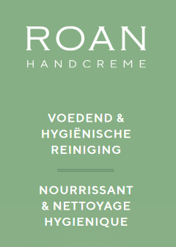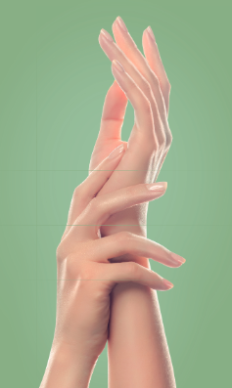

***How to Use:***

Apply ROAN from tube or dispenser and rub over entire surface of hands for a few seconds until penetrated. The antioxidants, Vitamin E and moisturizing additives immediately express their beneficial characteristics, 70% ethanol finishes the job.

**Result:**

Your hands are fully hydrated, cared for and protects you against contamination.

With ROAN you are in good hands 😊

**General information:**

ARTNOG is available in tubes of 75ml and in larger volumes of 500ml as a dispenser.

ROAN contains 70% ethanol and is a cosmetic, registered for the full European Union-territory under CPNP n° 3654004.

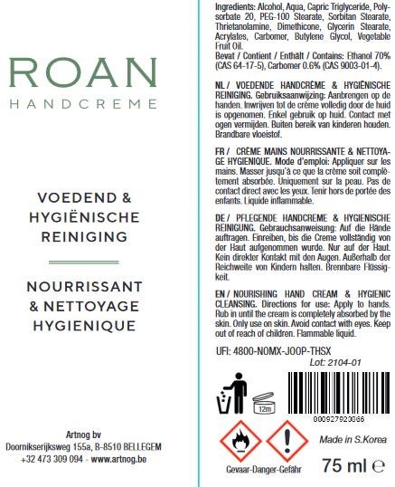

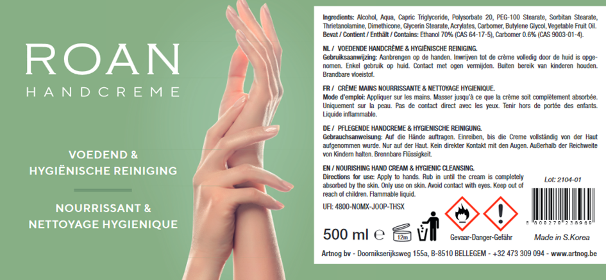

ARTNOG BV

Doornikserijksweg 155a

B-8510 BELLEGEM (Belgium)

0473 30 90 94

jurgen@artnog.be